CMSC 203 Lab 5
Memory Mapping
I am putting each problem on a separate page so the image is readable instead of tiny
- Draw the memory map of the following one-dimensional array of type int.
int[] x = new int[8];

Stack: Heap:
(I combined them into one image)
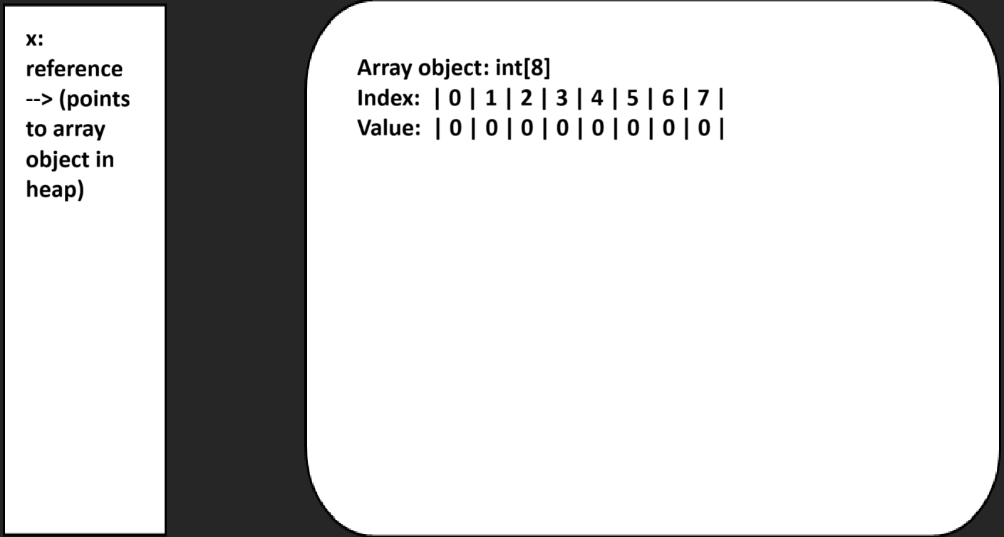
- Draw the memory map of the following two-dimensional ragged array of ints.

int[][] y = {{4, 8, 15}, {16, 23, 42, 10}, {8, 30}};

Stack: Heap:
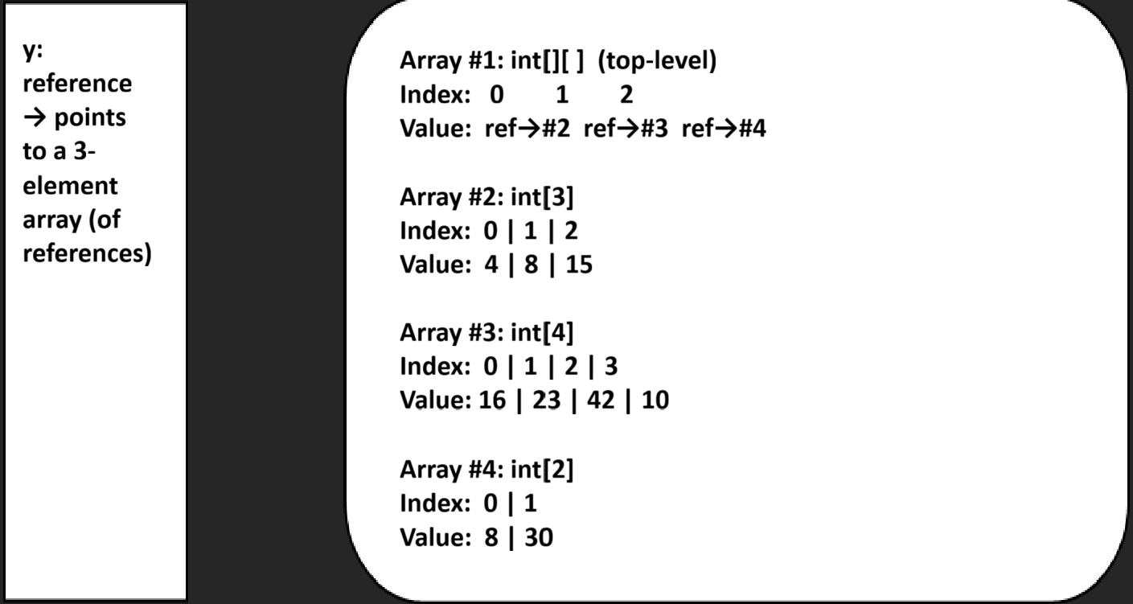
- Draw the memory map of the following one-dimensional array of type String.

String[] z = new String[4];
for (int i = 0; i < z.length; i++) {
z[i] = "element " + i;
}
Stack: Heap:
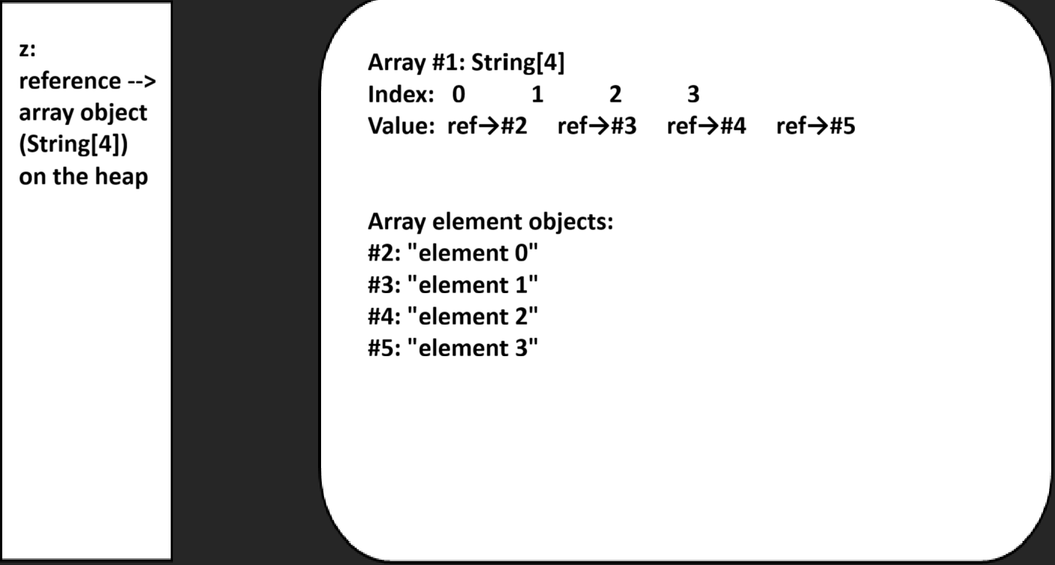

  - Write a shallow copy of the following in code. (Assume the five animal objects are already instantiated.)
Animal[] zoo = {tiger1, elephant2, giraffe3, monkey4, ape5};
Animal[] copy;

Animal[] copy = zoo.clone();
  - Draw the memory map.
Stack: Heap:
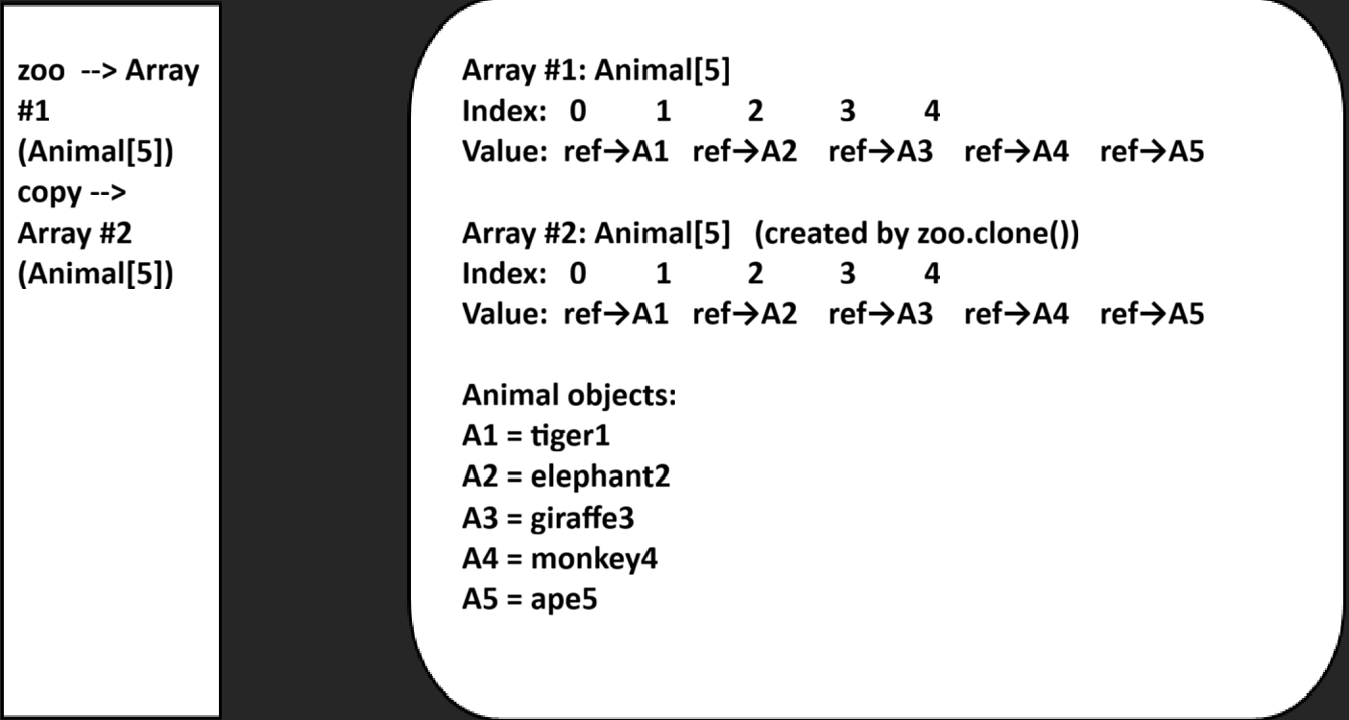

- Write the deep copy of the following in code.
Animal[] zoo = {tiger1, elephant2, giraffe3, monkey4, ape5};
Animal[] copy;
Animal[] copy = new Animal[zoo.length];

for (int i = 0; i < zoo.length; i++) {
copy[i] = new Animal(zoo[i]); // idk what constructor the Animal class uses sorry
}
- Draw the memory map.
Stack: Heap:
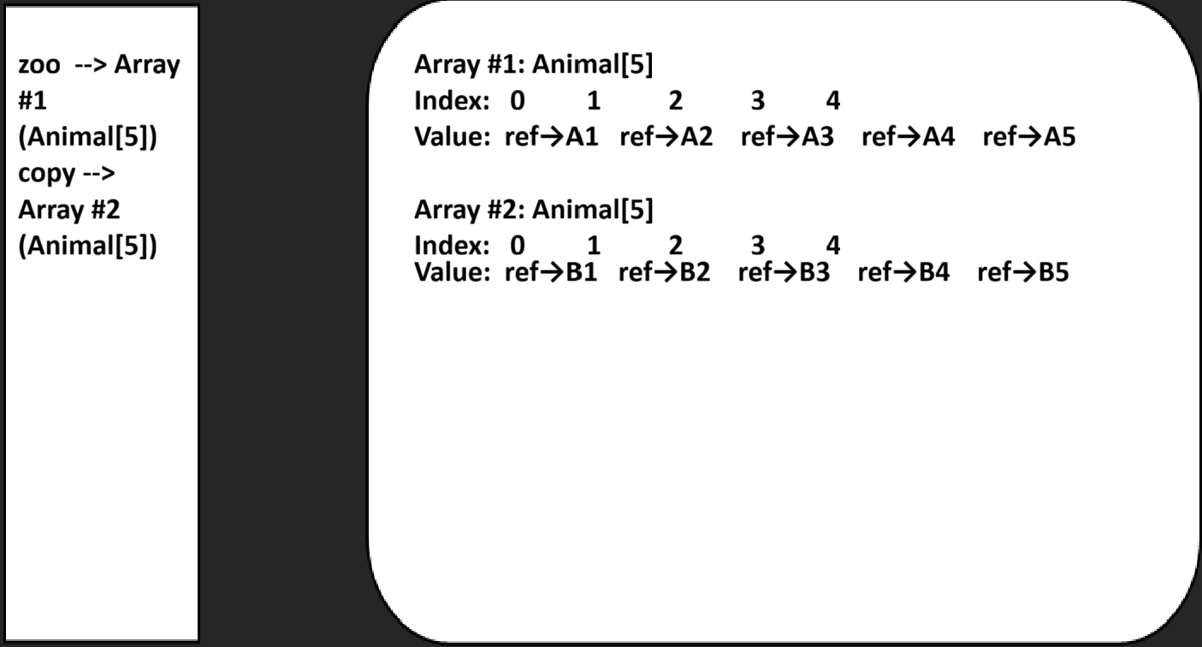
- What is garbage collection? Where does it happen?
Garbage collection is the process that finds object in memory that are no longer usable and destroys them
It happens in the heap because that’s where objects are stored

- What is the difference between the two operators, equals() and ==?
The == operator checks if both objects are the exact same (for basic classes like int or double it will check their actual values), as in the same memory address
The .equals() (assuming it is overridden) will check the fields of the object to see if it is equivalent
If not overridden it acts the same as == above

